Steps to Execute Multiple Iterations of any Test Script using CAFT

- Go to CAFT folder and open ‘Run Manager.xls’ excel sheet.
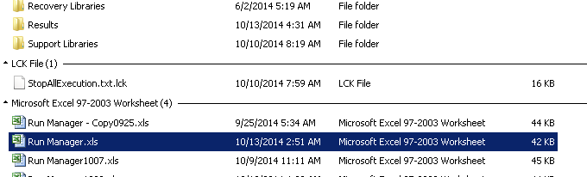
- Change Execute status to ‘TRUE’, Start_Iteration i.e. Column E as 1 and End_Iteration i.e. Column F as number of iteration needs to executed. Also set the value of “Iteration_Mode” i.e. column D = “rngIterations”
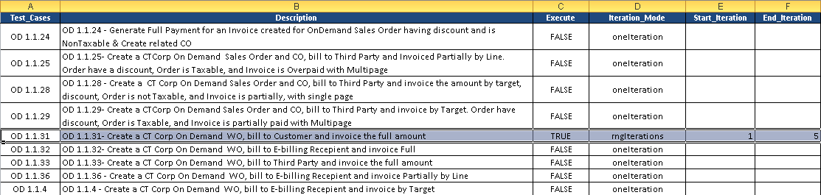
- Go to Datatable folder:
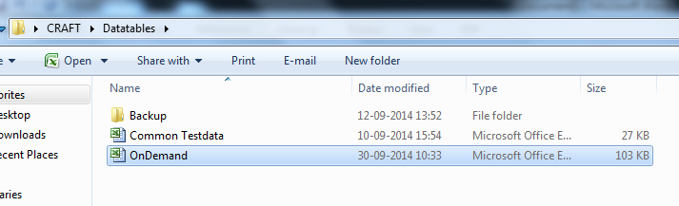
- Open ‘OnDemand’ excel sheet
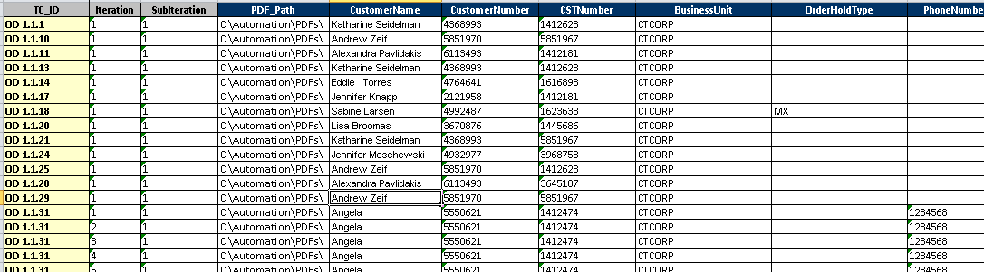
  - For Multiple iteration with different or same data:
    - Go to ‘OD_Data’ sheet. Add rows equal to the number of iteration with same or different data. And set Iteration column in the sequence number:
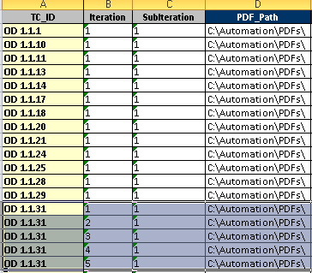

    - Go to ‘General_Data’ sheet. Add rows equal to the number of iteration with same or different data. And set Iteration column in the sequence number:
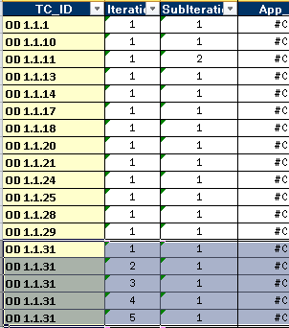
- Execute the script by double click on ‘InitScript_CRAFT.vbs’.

Sample Results file attached for reference below

